SQL PROJECTBOOKS

1) Retrieve all books in the "Fiction" genre

SELECT *
FROM books
WHERE genre = 'Fiction';

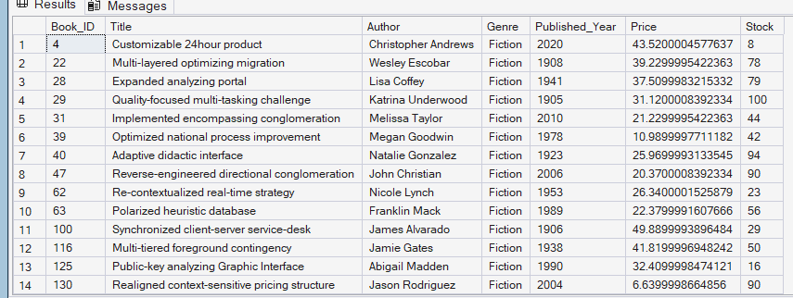

2) Find books published after the year 1950

SELECT *
FROM books
WHERE published_year > 1950;

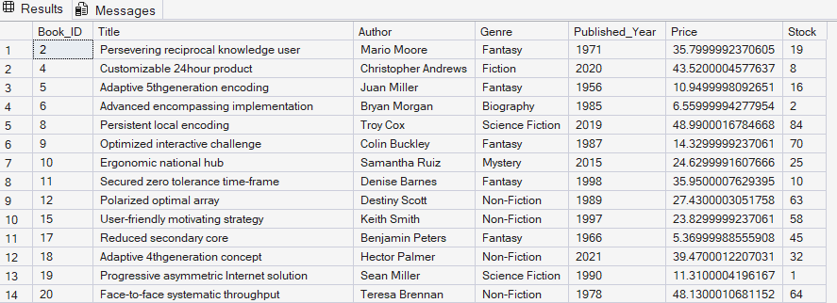

3 List all customers from the Canada

SELECT *
FROM customers
WHERE country = 'Canada';

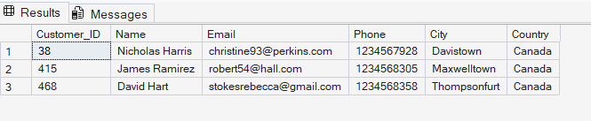

4) Show orders placed in November 2023

SELECT *
FROM orders
WHERE order_date >= '2023-11-01'
AND order_date < '2023-12-01';

5) Retrieve the total stock of books available SQL QUERY

SELECT SUM(stock) AS total_stock
FROM books;

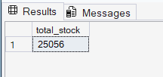

6) Find the details of the most expensive book

SELECT *
FROM books
WHERE price = (SELECT MAX(price) FROM books);

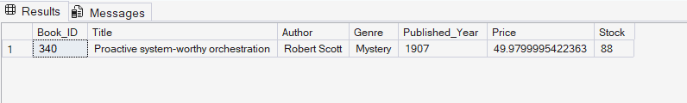

7) Show all customers who ordered more than 1 quantity of a book

SELECT *
FROM orders
WHERE quantity > 1;

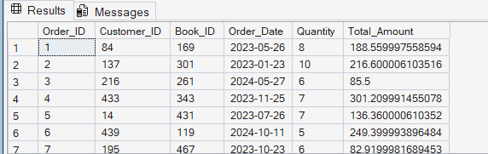

8) Retrieve all orders where the total amount exceeds $20

SELECT *
FROM orders
WHERE total_amount > 20;

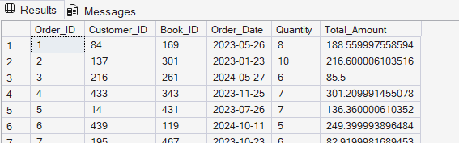

9) List all genres available in the Books table

SELECT DISTINCT genre
FROM Books;

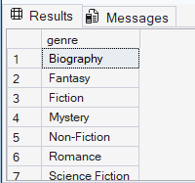

10) Find the book with the lowest stock

SELECT *
FROM Books
WHERE stock = (SELECT MIN(stock) FROM Books);

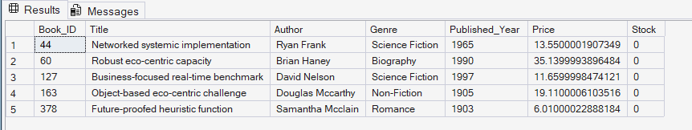

11) Calculate the total revenue generated from all orders

SELECT SUM(total_amount) AS total_revenue
FROM orders;

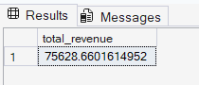

# ADVANCED QUESTIONS #

1) Retrieve the total number of books sold for each genre

SELECT b.Genre, SUM(o.Quantity)AS Total_Books_sold
FROM Orders o
JOIN Books b ON o.book_id = b.book_id
GROUP BY b.Genre

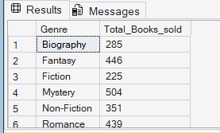

2) Find the average price of books in the 'Fantasy' genre

SELECT AVG(price)AS Average_Price
FROM BOOKS
WHERE Genre = 'Fantasy';

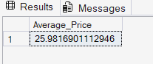

3) List customers who have placed at least 2 orders

SELECT o.customer_id, c.name,
COUNT(o.ORDER_id) AS ORDER_COUNT
FROM orders o
JOIN customers c
ON o.customer_id = c.customer_id
HAVING COUNT(order_id) >=2;

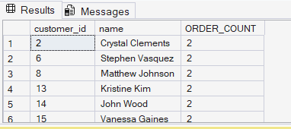

4) Find the most frequently ordered book

SELECT
top 2
o.Book_id,b.title,
COUNT(o.order_id) AS ORDER_COUNT
FROM orders o
JOIN books b
ON o.book_id=b.book_id
GROUP BY o.book_id, b.title
ORDER BY ORDER_COUNT DESC

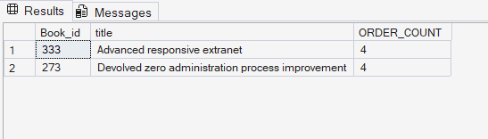

5) Show the top most expensive books of 'Fantasy' genre

SELECT TOP 3 * FROM BOOKS
WHERE GENRE='Fantasy'
ORDER BY Price DESC;

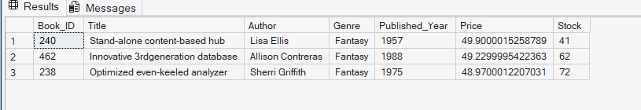

6) Retrieve the total quantity of books sold by each author

SELECT b.author,
SUM(o.quantity) AS total_quantity_sold
FROM books b
JOIN orders o
ON b.book_id = o.book_id
GROUP BY b.author
ORDER BY total_quantity_sold DESC;

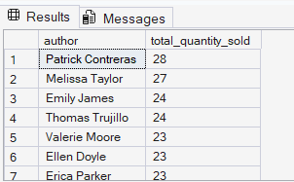

7) List the cities where customers who spent over $30 are located

SELECT DISTINCT c.city
FROM customers c
JOIN orders o
ON c.customer_id = o.customer_id
WHERE o.total_amount > 30;

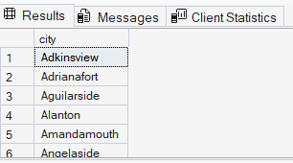

8) Find the customer who spent the most on orders

SELECT top 1
c.customer_id,
c.name,
SUM(o.total_amount) AS total_spent
FROM customers c
JOIN orders o
ON c.customer_id = o.customer_id
GROUP BY c.customer_id, c.name
ORDER BY total_spent DESC

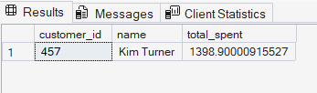

9) Calculate the stock remaining after fulfilling all orders

Select b.book_id,b.title,b.stock,coalesce(sum(o.quantity),0)as order_quantity,
b.stock-coalesce(sum(o.quantity),0)as remaining_quantity
From books b
left join orders o
On b.book_id=o.book_id
Group By b.book_id b.title,b.stock
Order By b.book_id;

